EXP.NO: 2 | Write JavaScript Programme to validate the following fields of the HTML Registration page.
DATE: 06/02/2025

AIM:
To write JavaScript code to validate user input in a registration form. The validation will ensure that the data entered by the user meets specific criteria for each field. This will help in maintaining data integrity and prevent invalid submissions.

ALGORITHM:
- Input:
  - The user fills in the following fields: First Name, Password, E-mail, Mobile Number, Last Name, and Address.

Validation Steps:
- Validate First Name:
  - Check if the first name contains only alphabets.
  - Ensure the length of the First Name is at least 6 characters.
  - If any of these conditions fail, display an error message indicating the required input.

Validate Password:
  - Check if the password is at least 6 characters long.
  - If it is less than 6 characters, display an error message.

Validate E-mail:
  - Use a regular expression to check if the email follows the standard pattern: name@domain.com.
  - Ensure that the email contains no invalid characters and matches the required pattern.
  - If it doesn't match, display an error message indicating an invalid email format.

Validate Mobile Number:
  - Check if the mobile number contains exactly 10 digits.
  - Ensure there are no alphabets or special characters.
  - If the number is invalid, display an error message indicating the correct format.

Validate Last Name:
  - Ensure the Last Name field is not empty.
  - If it is empty, display an error message.

Validate Address:
  - Ensure the Address field is not empty.
  - If it is empty, display an error message.

Code:

<!DOCTYPE html>
<html>
<head>
<title>Weather Information Website</title>

<style>
body {
margin: 0;
font-family: Arial, sans-serif;
background: linear-gradient(to right, #74ebd5, #acb6e5);
}

.header {
background: #0a2540;
color: white;
padding: 15px;
display: flex;
align-items: center;
}

.logo {
width: 70px;
height: 70px;
border-radius: 50%;
background: radial-gradient(circle, #fff176, #ff9800);
display: flex;
align-items: center;
justify-content: center;
font-size: 34px;
box-shadow: 0 0 15px rgba(255,255,255,0.8);
margin-right: 15px;
}

.title {
font-size: 26px;
font-weight: bold;
}

.container {
width: 450px;
background: white;
margin: 40px auto;
padding: 25px;
border-radius: 12px;
box-shadow: 0 10px 25px rgba(0,0,0,0.25);
}

h2 {
text-align: center;
color: #0a2540;
}

label {
font-weight: bold;
}

input, textarea {
width: 100%;
padding: 8px;
margin: 6px 0 15px 0;
border-radius: 6px;
border: 1px solid #ccc;
}

button {
width: 100%;
padding: 10px;
background: #0a2540;
color: white;
border: none;
border-radius: 6px;
font-size: 16px;
cursor: pointer;
}

button:hover {
background: #143a63;
}

.footer {
text-align: center;
color: white;
padding: 10px;
}

#weatherPage {
display: none;
background: #e3f2fd;
min-height: 100vh;
}

.weather-header {
background: #0277bd;
color: white;
padding: 20px;
text-align: center;
font-size: 28px;
}

.content {
padding: 30px;
text-align: center;
}

.card {
background: white;
padding: 20px;
margin: 15px;
display: inline-block;
width: 250px;
border-radius: 10px;
box-shadow: 0 0 15px rgba(0,0,0,0.2);
}
</style>

<script>
function validateForm() {
var fname = document.getElementById("fname").value;
var lname = document.getElementById("lname").value;
var password = document.getElementById("password").value;
var email = document.getElementById("email").value;
var mobile = document.getElementById("mobile").value;
var address = document.getElementById("address").value;

var namePattern = /^[A-Za-z]{6,}$/;
var emailPattern = /^[a-zA-Z0-9._]+@[a-zA-Z]+\.[a-zA-Z]{2,}$/;
var mobilePattern = /^[0-9]{10}$/;

if (!namePattern.test(fname)) {
alert("First Name must contain alphabets only and minimum 6 characters");
return false;
}

if (lname.trim() === "") {
alert("Last Name cannot be empty");
return false;
}

if (password.length < 6) {
alert("Password must be at least 6 characters long");
return false;
}

if (!emailPattern.test(email)) {
alert("Enter a valid Email ID");
return false;
}

if (!mobilePattern.test(mobile)) {
alert("Mobile Number must be exactly 10 digits");
return false;
}

if (address.trim() === "") {
alert("Address cannot be empty");
return false;
}

alert("Registration Successful!");

document.getElementById("registerPage").style.display = "none";
document.getElementById("weatherPage").style.display = "block";

return false;
}
</script>
</head>

<body>

<div id="registerPage">
<div class="header">
<div class="logo"></div>
<div class="title">Weather Information Website</div>
</div>

<div class="container">
<h2>User Registration</h2>

<form onsubmit="return validateForm()">
<label>First Name</label>
<input type="text" id="fname">

<label>Last Name</label>
<input type="text" id="lname">

<label>Password</label>
<input type="password" id="password">

<label>Email ID</label>
<input type="text" id="email">

<label>Mobile Number</label>
<input type="text" id="mobile">

<label>Address</label>
<textarea id="address"></textarea>

<button type="submit">Register</button>
</form>
</div>

<div class="footer">
© 2026 Weather Info | Smart Climate Updates
</div>
</div>

<div id="weatherPage">
<div class="weather-header">
Welcome to Weather Information Website
</div>

<div class="content">
<div class="card">
<h3>Temperature</h3>
<p>Live temperature updates</p>
</div>

<div class="card">
<h3>Rainfall</h3>
<p>Rain alerts & forecasts</p>
</div>

<div class="card">
<h3>Wind Speed</h3>
<p>Wind direction & speed</p>
</div>
</div>
</div>

</body>
</html>

Output:

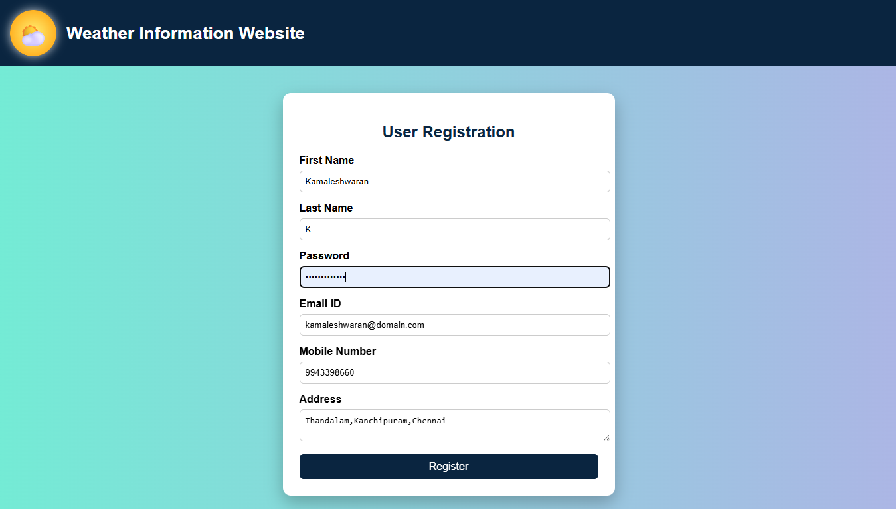

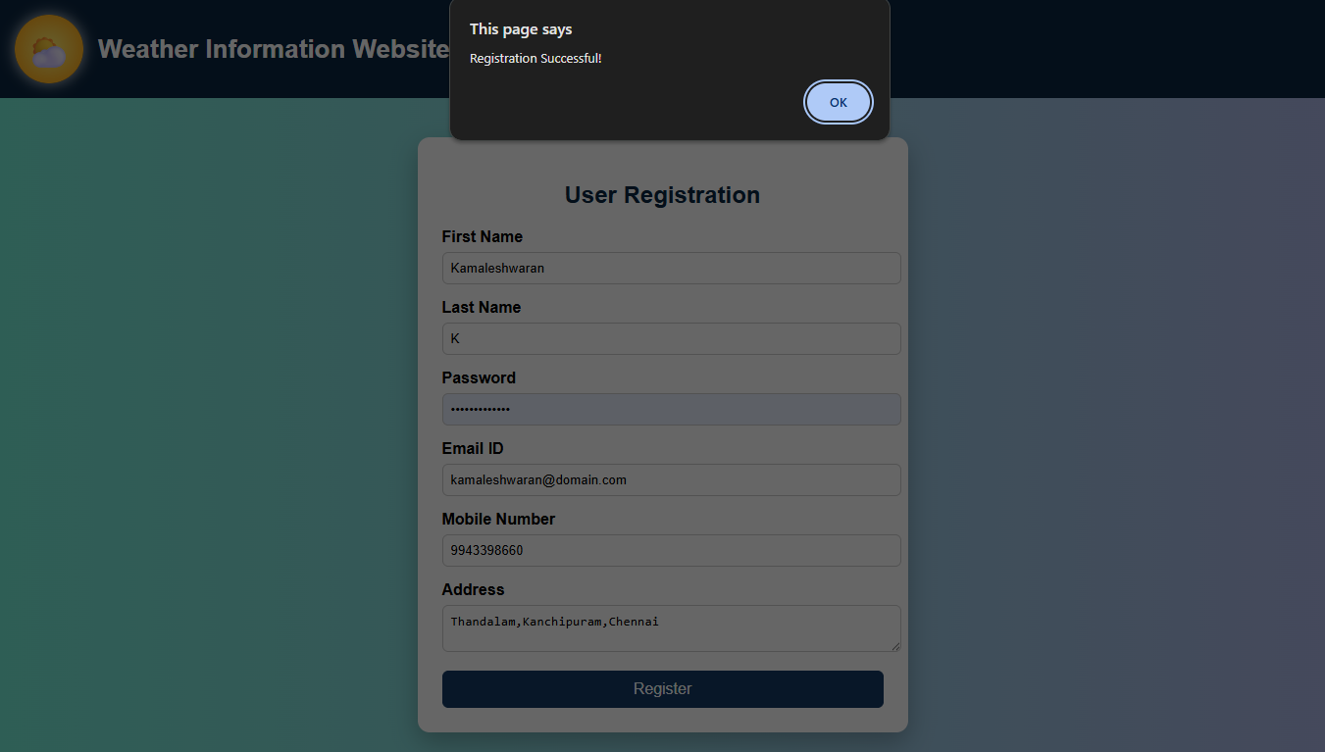

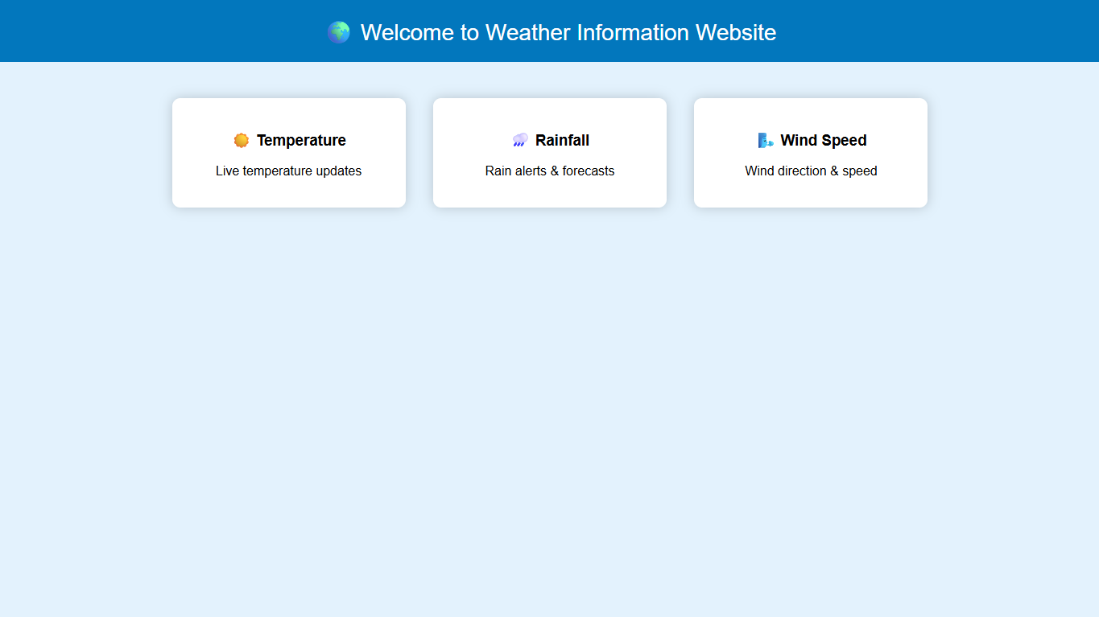

RESULT:
HTML page with Form is created and is validated using Javascript

